1.Sample Script File created on Local:

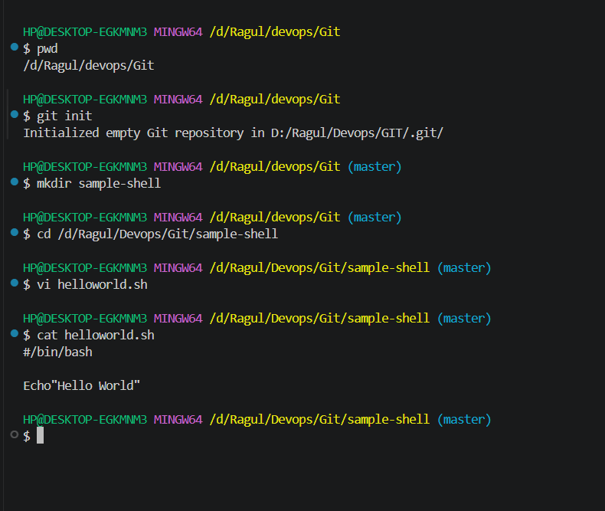
2. Adding new Remote repo and staging the sample script file:
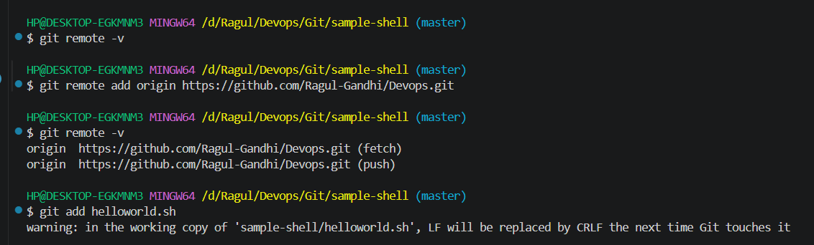
3.File Commited in the repo:
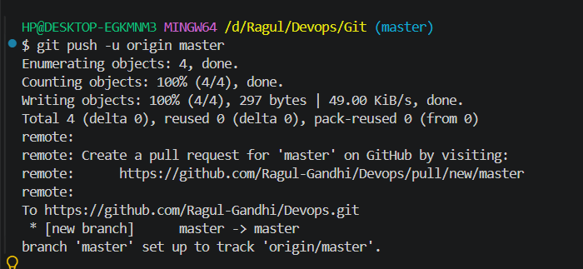
4.Sample script added in the GIT HUB:

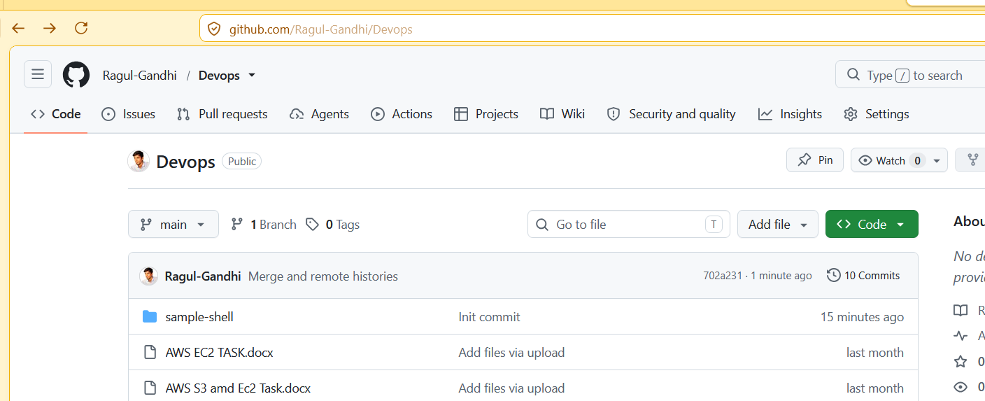
5.GIT Stash{Saves the changes temporarily without commit]:
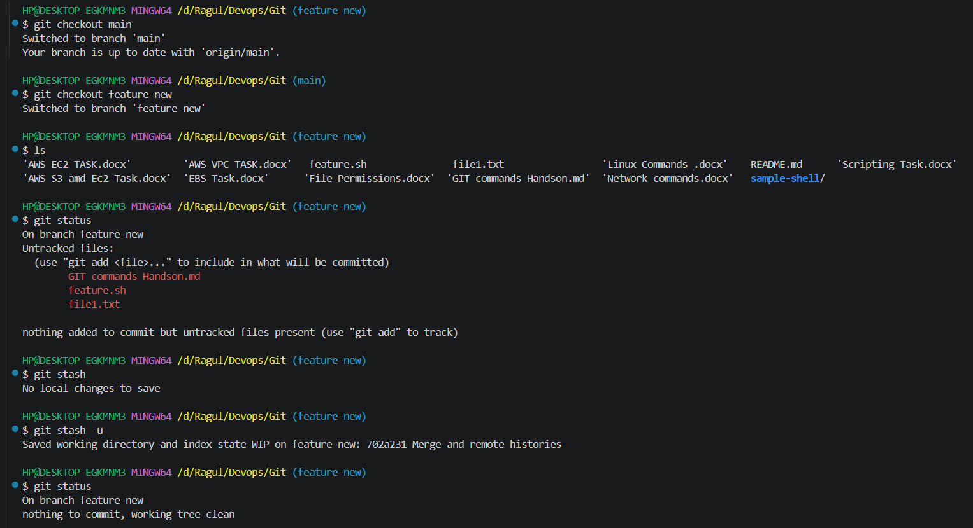
6.GIT Merge:[Merges the branch with the main or master]
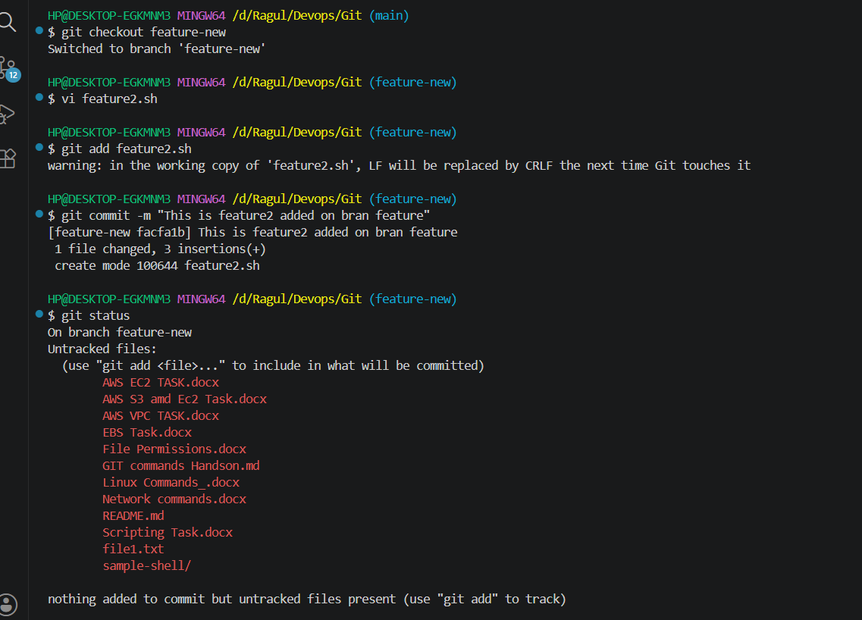
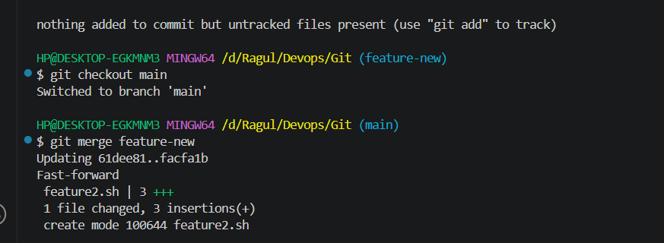
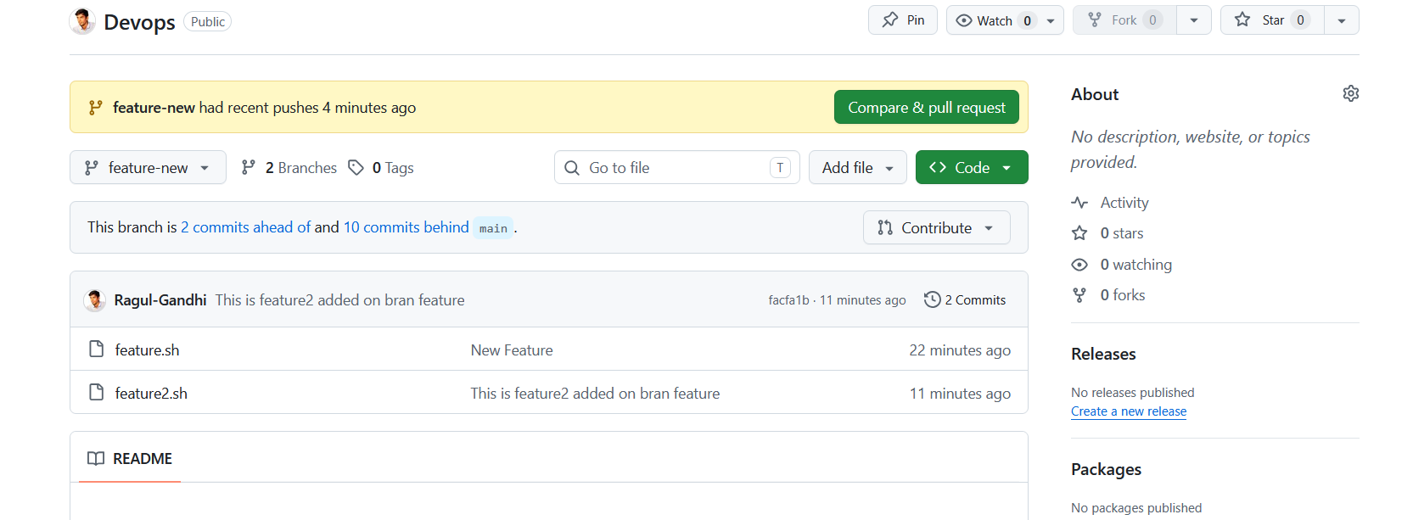
7.GIT Rebase:
a.) changes made on main
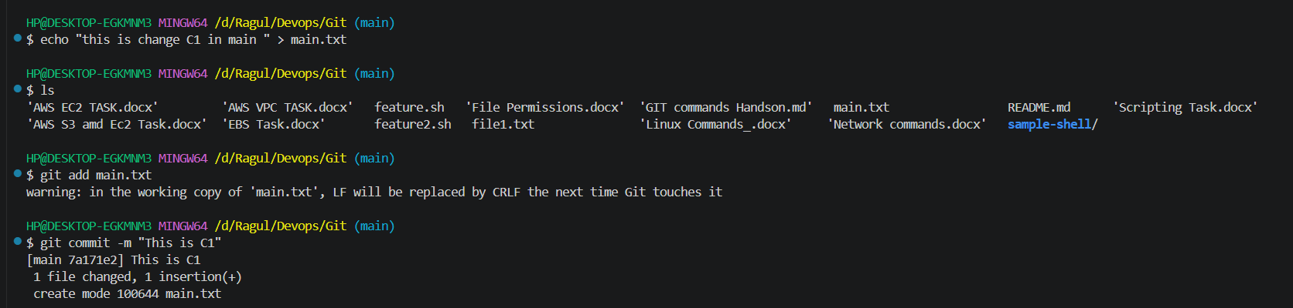
b.) changes made on the feature branch
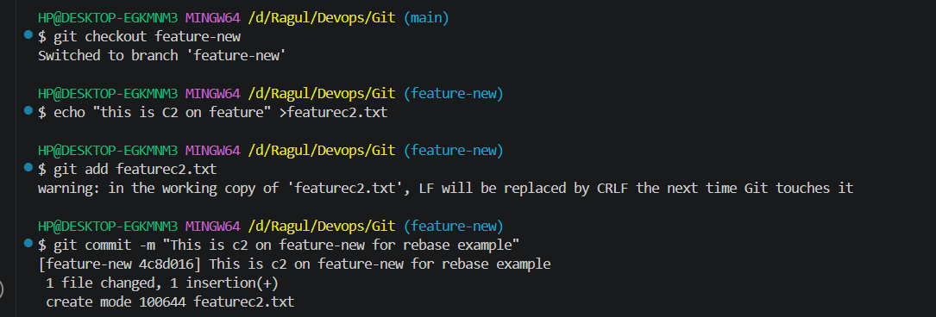
c.) Changes made again on the main branch:
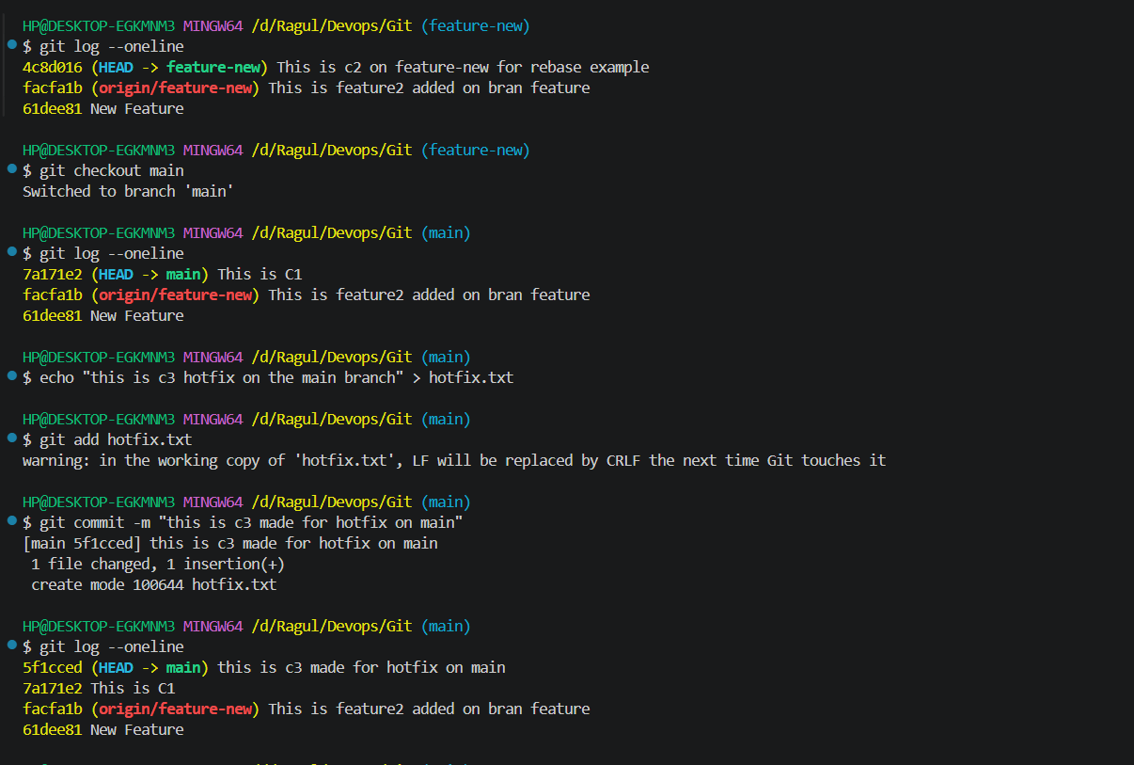
D.) Rebase the feature agin to main:
